Morriston Rapid Play Tournament
Saturday July 4th 2026
To celebrate the 150th anniversary of our hosts Morriston Rugby Club
Entry fee £5
Five Rounds with each player having a fixed 30 minutes on their clock
Adult and Junior sections with subsections (Open, Major, etc) in each if entrant numbers merit it
Timetable
Round 1. 10 – 11
Round 2. 11:15 – 12:15
Round 3. 12:30 to 13:30
Free Buffett Lunch 13:30 – 14:30
Round 4. 14:30 – 15:30
Round 5. 15:45 – 16:45
Trophee Presentation 17:00

Prizes
First Prize – Cut Glass Memorial Cup
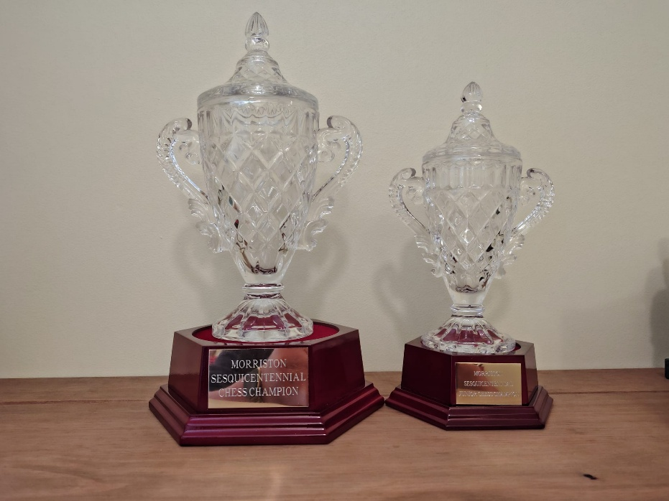
Additional Prizes dependant on entry numbers and sections
Entries
Email to Les Philpin at – newsilure@hotmail.com
Entry Fee payment to –
Morriston Chess Club
Bank account number - 90776424
Sort code - 20-84-41
Please enter as early as possible as space is limited and late entrants cannot be guaranteed acceptance.

Buffet
Will be free to all entrants.
Any non-player wishing a buffet needs to notify Les Philpin via email well in advance of the event so that the appropriate buffet quantity can be ordered.

